**EC2 Basics Lab**

1. A screenshot of a computer

   Description automatically generatedLaunch Instances Ec2 Basic1
2. A screenshot of a computer

   Description automatically generatedSelecting appropriate Instance Type t2.micro
3. A screenshot of a computer

   Description automatically generatedCreate new Key Value Pair Basic1
4. A screenshot of a chat

   Description automatically generatedSet address in security group as anywhere for accessing site from any Ip Address
5. Launched Instance and Status Is Running

1. A screenshot of a computer

   Description automatically generatedSelecting Elastic IP’s for Ec2 Instance
2. A screenshot of a computer

   Description automatically generatedAllocating Elastic IP address
3. A screenshot of a computer

   Description automatically generatedScroll down and allocate It.
4. A screenshot of a computer

   Description automatically generatedSelect Instances id and private Ip Address.
5. **A screenshot of a computer

   Description automatically generatedElastic Ip Address get associated with our EC2 Instance**
6. **A screenshot of a computer

   Description automatically generatedConnecting to the instance via SSH**
7. 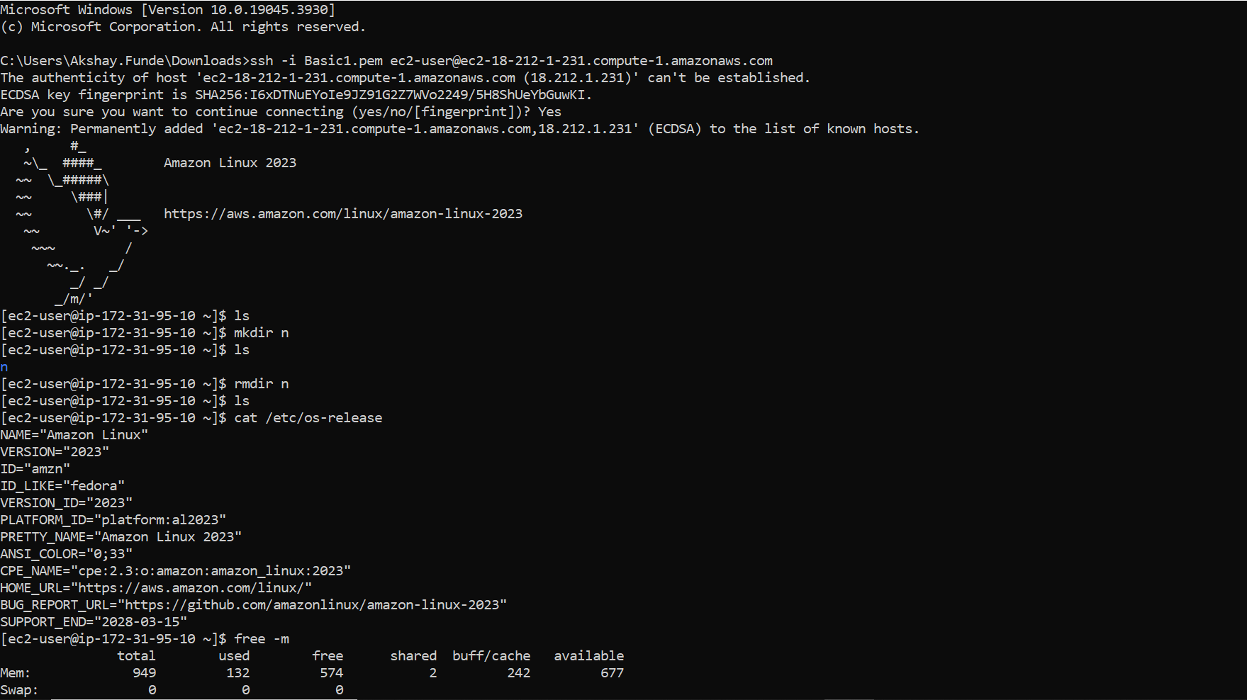**Access EC2 Instance connected via SSH to the local pc.**

**S3 Storage Fundamentals Lab**

1. 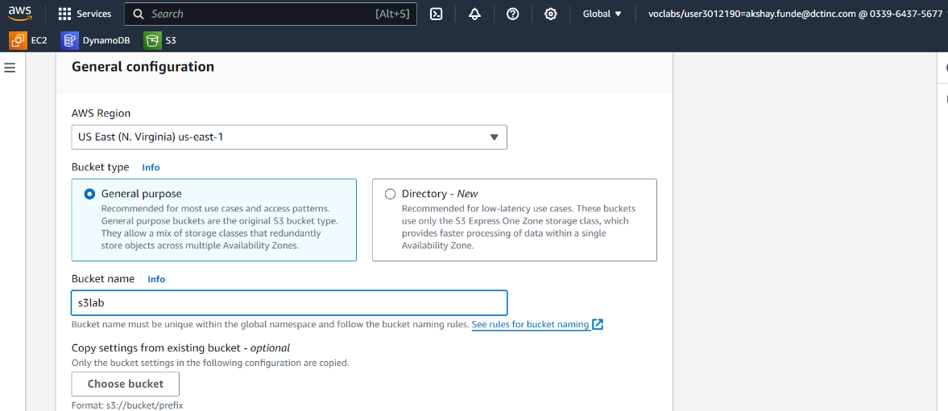**Creating s3 bucket with unique name**
2. 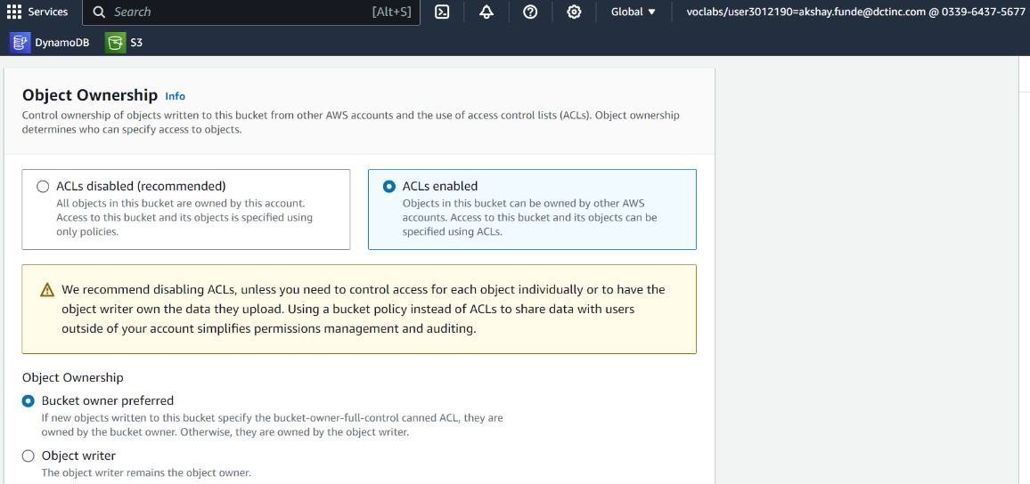**Object Ownership: Select ACL’s Enabled for the public.**
3. A screenshot of a computer

   Description automatically generatedUntick block all public access option because the object is public and tick acknowledgement request.
4. A screenshot of a computer

   Description automatically generated**Now created the bucket.**
5. 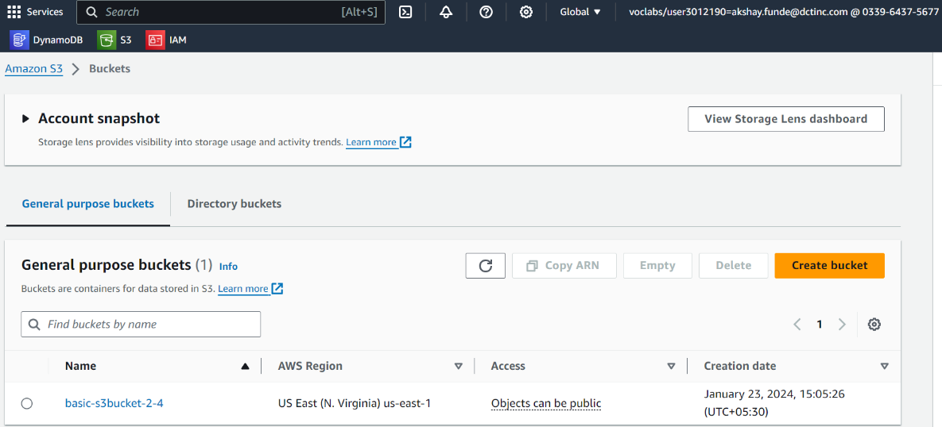 **The bucket was created successfully. After that select the bucket to upload the data**
6. **A screenshot of a computer

   Description automatically generatedFile uploaded from the add files button.**
7. 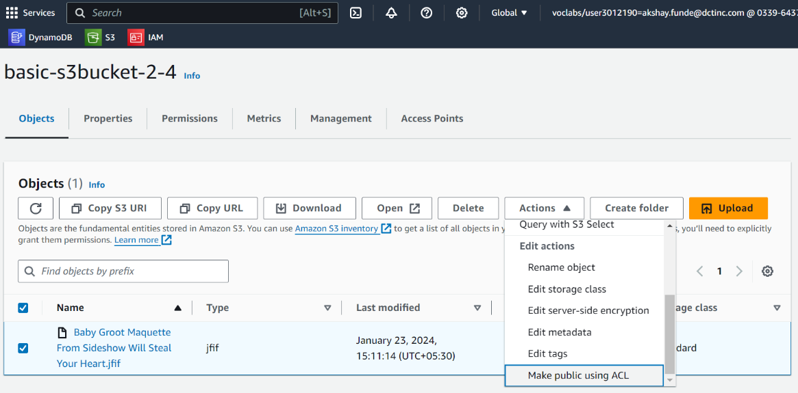**Make uploaded file public for public access by clicking on action button and then select the make public using ACL option.**
8. **Clicked on the make public option.**

1. A screenshot of a computer

   Description automatically generated**Public URL is generated to access the file.**
2. **Object file uploaded in S3 Bucket**

